**DESIGN PROJECT II**

**SPRING 2020**

**ECE 458**

# **Class Meetings:** SENG- 222 Tuesdays and Thursdays 2:00 to 3:15 PM.

# It may be necessary to occasionally reschedule classes to accommodate work schedules, travel, etc. This will be planned in advance and implemented so as to accommodate everyone’s schedules.

# **Instructor:** Dr. Paul Fortier - Professor UMass Dartmouth

Phone: 508-999-8544

Email: pfortier@umassd.edu

Office Hours: TBD - Office is SENG 211A

# **Course Description and Learning Objectives**

This course is the second in the Senior Capstone Design sequence, which provides the experience of executing an engineering design project from start to finish. This course focuses on the detailed design, construction, integration, and testing of the lower level components and subsystems defined in ECE 457. It continues to provide experience in working in teams, maintaining a design notebook, preparing and executing plans and schedules, and communicating with a range of audiences. The semester culminates in a presentation/ demonstration of the project to a campus-wide audience and external judges.

# The specific learning objectives of this course are a subset of learning outcomes of the ECE Department for the ELE and CpE programs. These outcomes are correlated to ABET program outcomes as shown below. (Outcomes are listed as (<ABET Outcome> / <ECE Program Outcomes>)

1. Impact of engineering on society. (4 /4a, 4b)

2. Implement solution to complex engineering problem. (1/ 1b)

3. Make appropriate design tradeoffs. (1 /1b)

4. Formal design reviews (Oral and Written presentations). (3 /3a, 3b)

5. Working effectively in multidisciplinary teams. (5 / 5a, 5b, 5c)

6. Performance testing, evaluation and review. (7 / 7)

7. Demonstration and validation (demonstrate acquire new knowledge). (7 / 7)

The course also satisfies learning outcomes at the university studies level. These outcomes are derived from the university studies requirement 5:

1. Identify the needs and resources of the communities to which they belong.

2. Apply knowledge and skills gained through academic study to real problems and/or opportunities within their communities.

3. Describe the connections between learning on campus and the issues and needs of broader academic, professional or civic communities.

4. Articulate the value of engagement to other members of their communities.

Course Content and General Information

Text- Design for Electrical and Computer Engineers: Theory, Concepts, and Practice, by Ralph M. Ford and Chris S. Coulston, published by McGraw-Hill, ISBN 978-0-07-338035-3

Assignments- This course has four written reports and one oral presentation.

Students are required to keep a design notebook that meets the requirements described below.

Computer Literacy- It is expected that students are familiar with standard word processing, presentation, and spreadsheet programs. Familiarity with database and scheduling applications may be useful but is not required.

Projects- Projects are continuations of those selected at the beginning of the academic year in ECE 457. A project’s scope, requirements, or objectives may be modified by the customer, faculty advisors, or the course coordinator if required to address problems or constraints that were either not present or evident in the fall semester. The customer and faculty advisor must approve any modifications.

Team Formation, Roles, and Responsibilities—Teams’ composition will be the same as in ECE 457.

# The link below describes workload and class planning policies, academic policies, and accommodation and support policies.

# https://www.umassd.edu/media/umassdartmouth/provost/omnibus_language_for_syllabi_-jan_11_2019.pdf

# Class Attendance- This is an upper level course, so there are no explicit attendance requirements. However, advance notice of absences is appreciated. Students are responsible for material covered in all class sessions.

Intellectual Property- Certain projects may have intellectual property, proprietary information, or other confidentiality requirements. Students were familiarized with their responsibilities with respect to these items in ECE 457. Students signed a waiver of Intellectual Property (IP) Rights in order to work on projects sponsored by outside organizations or those having an expectation of IP. This is consistent with industry practice. If there are any changes or new issues with respect to IP, notify the coordinator immediately.

Course Structure, Roles, and Operation- The majority of work in the course will be performed by the STUDENT TEAMS. These teams will interact with their CUSTOMER/SPONSOR to define the requirements, scope, constraints, budgets, schedules and key design parameters for their project. TEAM interaction with the CUSTOMER should be as frequent as necessary to successfully execute the project.

The teams must also interact regularly with their FACULTY ADVISOR for technical guidance, mentoring, and review/signing of engineering notebooks. The FACULTY ADVISOR may also be helpful in working with the CUSTOMER to resolve resource and other problems. Failure to interact with the FACULTY ADVISOR or CUSTOMER regularly will be reflected in the grade.

The COURSE COORDINATOR will facilitate weekly (Tues/ Thurs) lectures and discussions on the topic shown in the schedule. The intent of the weekly class sessions is to provide students with background and information on topics key to successfully completing their projects. The COURSE COORDINATOR is also available to assist with personnel issues, disconnects between the TEAM and CUSTOMER or TEAM and FACULTY ADVISOR.

Shared Drive- There is a folder named ECE458 on the m:drive. The ECE458 folder contains sub-folders for each student, each project , class assignments, and class lectures. Student and Project folders that are read/ write- enabled for each student and project team member respectively. Other folders are read-only.

All class lectures, instructions regarding activities, and grading rubrics for those activities will be posted on the m: drive under ECE 458. NOTE: Accessing either the ECE 457 or ECE 458 folder will take you to the ECE 457 folder from last semester. This will let you access material from ECE 457. New material specific to ECE 458 will be clearly labeled. Detailed instructions and templates for each assignment will be presented in class in advance of the assignment and posted on the m: drive in the ECE 457/458 Folder.

**Assignments and Grading**

The table below shows the class activities that will be graded and the percentage of the total grade for each class activity. Detailed instructions are summarized below. Grading rubrics will be provided in advance for each activity.

|  |  |  |
| --- | --- | --- |
| **Class Assignment** | **Weighting** | **% of Total Grade** |
| Plan and Schedule | 0/100 | 10 |
| Test Plan | 50/50 | 20 |
| Test Report | 50/50 | 20 |
| Final Report | 50/50 | 30 |
| Final Presentation and Demonstration * | 40/ 40 and External* | 10 |
| Project Notebooks | 0/100 | 10 |

Weights are: Customer/ Course Coordinator *Inputs from External Judges

Grading will be on a 0 to 100 point scale for each assignment using the University of Massachusetts Dartmouth grading scale (available on request). Grades will be scaled as required based on class overall performance and to normalize differences in grading standards among customers and advisors. Late submissions will be penalized 10% of the grade.

**Detailed Descriptions of Course Assignments**

**Project Notebooks**

Project notebooks must be maintained in ink by each student. Notebooks must be bound (no spiral or ring-type binders) with the front of each page numbered in ink. There should be no erasures (cross out unwanted entries) and all entries (or pages) should be dated. Your name and project title must be on the cover.

The notebook is a tool for documenting ALL your engineering work (see important note below) including problems, analysis, design consideration and problem resolution or approach, results of builds, test plans. Include all requirements, design decisions (with rationale for each) all calculations, preliminary designs, test set-ups, and test results. NEATNESS IS NOT IMPORTANT- THIS IS A WORKING DOCUMENT.

It is recognized that much of your work may be performed and/or documented on-line. Examples include MatLab and CAD programs and data, software, and data/ specs/ information downloaded from the Web. This information does not have to be included in your notebook but should be referenced in it. The reference should be specific enough that a reader of the notebook could find the information. You are responsible for maintaining your online documentation and programs. This is especially important for software- make sure you can identify the latest versions of your software (and retain earlier versions in case they are needed!)

Work that represents group effort should be documented as such, with a clear accountability of who was responsible for each piece. Notebooks must be signed and dated approximately every two weeks by your advisor.

Notebooks will be reviewed and graded at the end of the semester.

**Plan and Schedule**

The plan and schedule must include the following:

1. Title Page
2. System Overview
   1. Include System Block Diagrams, Software Diagrams, Hardware and Electronics Drawings as Applicable
   2. Reuse Earlier Material as Applicable
   3. Include any Updates Since the End of the Fall Semester
3. Table Showing Current Engineering Requirements
   1. Reuse Earlier Tables
   2. Include any Updates since the End of the Fall Semester
4. Plan and Schedule
5. Use the Format Shown below in Figure 1
6. Include the following information for each task:
   * + Task Name
     + Planned Start and End Date of Task
     + Estimated Total Hours for Task
     + Team Member Responsible for the Task

You will update your plan and schedule throughout the semester and add Actual Start Dates, Actual End Dates, and Actual Hours Spent on each Task

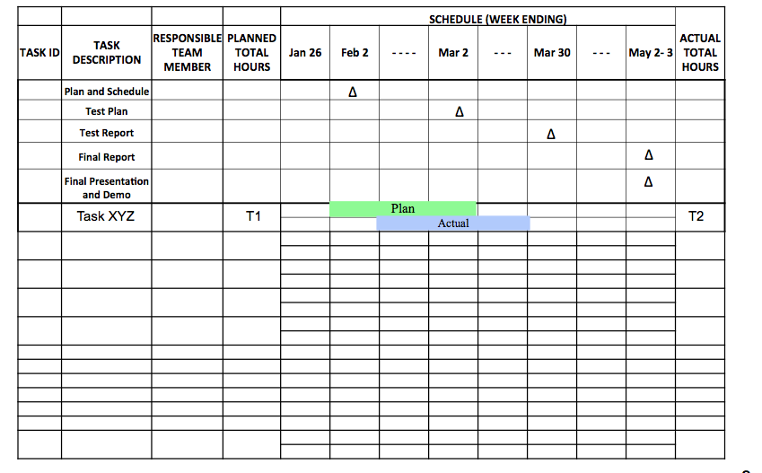

**Figure 1- Plan and Schedule Format**

**Test Plan**

The test plan describes the tests you will conduct to verify each requirement. It documents the following:

* + Test equipment required
  + Software required
  + Location(s) of testing
  + Applicable requirements documents, software documentation, etc.
  + Test Cases describing the step-by-step instructions for verifying each requirement
  + A Verification Cross Reference Matrix (VCRM) that summarizes the tests

The test plan is the document that must be “passed” by the customer for the project to be successful. The results of executing the test plan will be the Test Report (see below)

The format of the Test Plan is shown below in Figure 2. This will be discussed in more detail in class. Figure 3 shows the format for test cases. This will also be discussed in more detail in class.

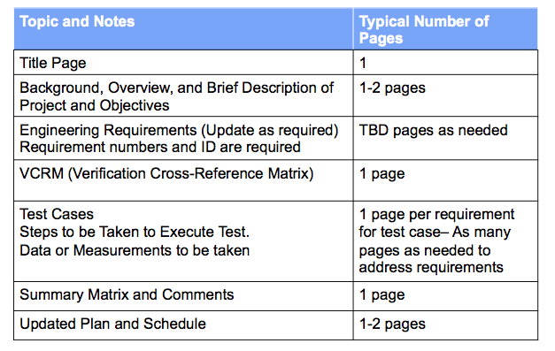

**Figure 2-- Test Plan Outline**

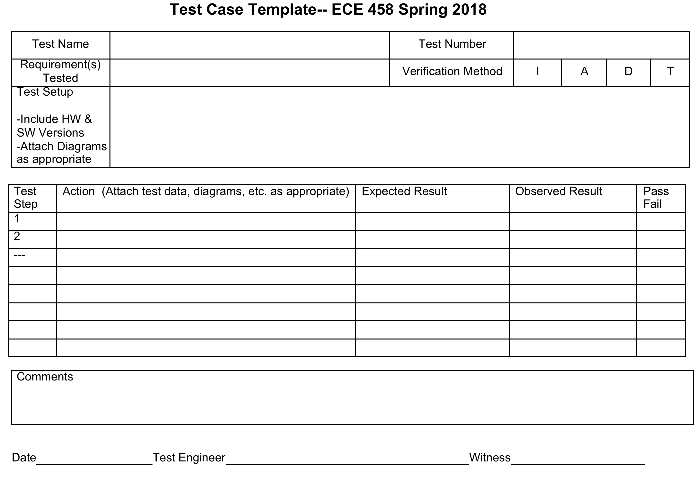

**Figure 3- Test Case Template**

**Test Report**

The Test Report has Essentially the Same Format as the Test Plan

* Results of the Tests are Added
* Updates to Requirements, Constraints, or the System Configuration as a Result of Information or Issues Identified During the Conduct of the Tests are Included

**Final Report**

The Final Report is a Comprehensive Description of Your Project From the Initial Customer Requirements Through the Final Test and Delivery

Below is an outline of the Final Report. Additional details will be provided in class

1.    Project Overview

2.    Customer Requirements

2.1. Requirements

3.    Engineering Requirements, Constraints, and Standards

3.1. Requirements

3.2. Constraints

3.3. Standards

4.    Functional Overview

5.    Alternatives Evaluated

5.1. Alternative 1

5.2. Alternative 2

6.    Technical Description of System

6.1. Detailed System Diagram

6.2. Subsystem 1 Description

6.3. Subsystem 2 Description

6.4. Subsystem N Description

7.    Test Plan and Results

7.1. VCRM

7.2. Test Cases and Test Results

7.3. Test Summary

8.    Risk Discussion

9.    Plan, Schedule, and Costs

9.1. Plan and Schedule- Final Update

9.2. Actual Hours vs. Planned Hours

9.3. Cost Summary

10. Summary

11. Lessons Learned

12. Documentation (here or in Appendices)

12.1.              Electrical

12.2.              Software

12.3.              Mechanical

12.4.              Other (If Applicable)

Appendix A

Appendix B

Appendix C

Appendix N

**Final Presentation**

The Final Presentation is the opportunity for you to present your project to faculty, family and friends, underclassmen, and the university at-large. Details regarding the presentation including time, location, areas of emphasis, and presentation tips will be provided in class. For reference, Figure 4 below shows an outline of a typical presentation.

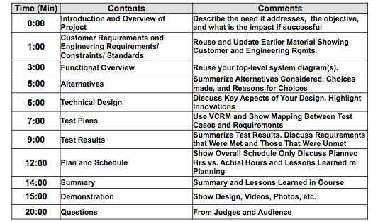

**Figure 4 Outline of Final Presentation**

**Schedule**

The schedule below shows the general topics to be addressed and references. If the schedule is modified, the syllabus file will be updated and the revised version of the syllabus will be placed on the ECE 458 folder on the m: drive

|  |  |  |  |  |  |
| --- | --- | --- | --- | --- | --- |
| **Week** | **Date** |  | **Subject** | **Notes** | **Text Chapter** |
| 1 | 21-Jan | Tues | ECE 457- Grading and Comments Expectations for ECE 458 and Design Notebooks | SENG 222 |  |
| 1 | 23-Jan | Thurs | Requirements for Plan and Schedule | SENG 222 |  |
| 2 | 28-Jan | Tues | No Class- WVM at IEEE Committee Meeting | SENG 221 |  |
| 2 | 30-Jan | Thurs | No Class- WVM at IEEE Committee Meeting |  |  |
| 3 | 4-Feb | Tues | **Plan and Schedule Due** | SENG 222 |  |
| 3 | 6-Feb | Thurs | Testing and Test Plans | SENG 222 | 7 |
| 4 | 11-Feb | Tues | Test Plan Examples | SENG 222 | 7 |
| 4 | 13-Feb | Thurs | Project Working Time and Questions and Help | SENG 221 |  |
| 5 | 18-Feb | Tues | NO CLASS- Following Monday Class Schedule |  |  |
| 5 | 20-Feb | Thurs | Project Working Time and Questions and Help | SENG 221 |  |
| 6 | 25-Feb | Tues | Project Working Time and Questions and Help | SENG 221 |  |
| 6 | 27-Feb | Thurs | **Test Plans Due** |  |  |
| 7 | 3-Mar | Tues | Project Working Time and Questions and Help | SENG 222 |  |
| 7 | 5-Mar | Thurs | Test Plan Discussion | SENG 221 |  |
| 8 | 10-Mar | Tues | NO CLASS --Spring Break |  |  |
| 8 | 12-Mar | Thurs | NO CLASS --Spring Break |  |  |
| 9 | 17-Mar | Tues | Project Working Time and Questions and Help | SENG 222 |  |
| **Week** | **Date** |  | **Subject** | **Notes** | **Text Chapter** |
| **9** | **19-Mar** | **Thurs** | **Class to Review Progress and Schedule for Rest of Semester** | **SENG 222** |  |
| 10 | 24-Mar | Tues | Project Working Time and Questions and Help |  |  |
| 10 | 26-Mar | Thurs | **Test Reports Due** |  |  |
| 11 | 31-Mar | Tues | Project Working Time and Questions and Help |  |  |
| **11** | **2-Apr** | **Thurs** | **Test Report Feedback**  **Final Report Directions** | **SENG 222** | **12** |
| 12 | 7-Apr | Tues | Project Working Time and Questions and Help |  | 12 |
| **12** | **9-Apr** | **Thurs** | **Final Presentation Directions** | **SENG 222** | **12** |
| 13 | 14-Apr | Tues | Project Working Time and Questions and Help |  | 12 |
| **13** | **16-Apr** | **Thurs** | **Final Report and Presentation Update (1)** | **SENG 222** | **12** |
| 14 | 21-Apr | Tues | Project Working Time and Questions and Help |  | 12 |
| **14** | **23-Apr** | **Thurs** | **Final Report and Presentation Update**  **Team Evaluations**  **Course Evaluation** | **SENG 222** | **12** |
| 15 | 28- Apr | Tues | **FINAL REPORTS, DESIGN NOTEBOOKS, and PRESENTATIONS DUE BY 4:00 PM** | **SENG 222** |  |
| 15 | 30-Apr | Thurs | **FINAL PRESENTATIONS** | **Woodward**  **Commons** |  |